Draft FSI thresholds for BLTR and MNWH

**The FSI density thresholds for mountain whitefish (MNWH) are:**

100 fish/km = very high density

70 fish/km = high density

50 fish/km = moderate density

20 fish/km =low density

<20 fish/km = very low density

**BLTR FSI thresholds for backpack electrofishing have been drafted as:**

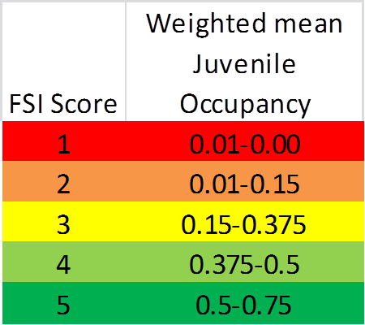

Where you could think of weighted mean juvenile occupancy as naïve occupancy in a watershed (i.e., 10 sites/100 sites detected BLTR, or 0.10). For the purposed of the power analysis, I propose you consider all fish instead of only juvenile.

But, we’d prefer to move to CUE (fish/100m) and have drafted the FSI thresholds for total CUE as:

|  |  |  |  |
| --- | --- | --- | --- |
| Theoretical FSI Category | Reduction Relative to Reference Condition (%) | CPUE (BLTR / 100m) | CPUE Range |
| 5 | 0 | 33.09 | > 33.1 |
| 4 | 30 | 23.163 | 23.2-33.1 |
| 3 | 50 | 16.545 | 16.5-23.2 |
| 2 | 80 | 6.618 | 6.6-16.5 |
| 1 | 100 | 0 | 0 - 6.6 |

**BLTR FSI thresholds for float electrofishing have been drafted as:**

|  |  |  |  |
| --- | --- | --- | --- |
| Theoretical FSI Category | Reduction Relative to Reference Condition (%) | CPUE (BLTR / km) | CPUE Range |
| 5 | 0 | 1 | >1 |
| 4 | 30 | 0.8 | 0.8-1 |
| 3 | 50 | 0.5 | 0.5-0.8 |
| 2 | 80 | 0.2 | 0.2-0.5 |
| 1 | 100 | 0 | 0-0.2 |